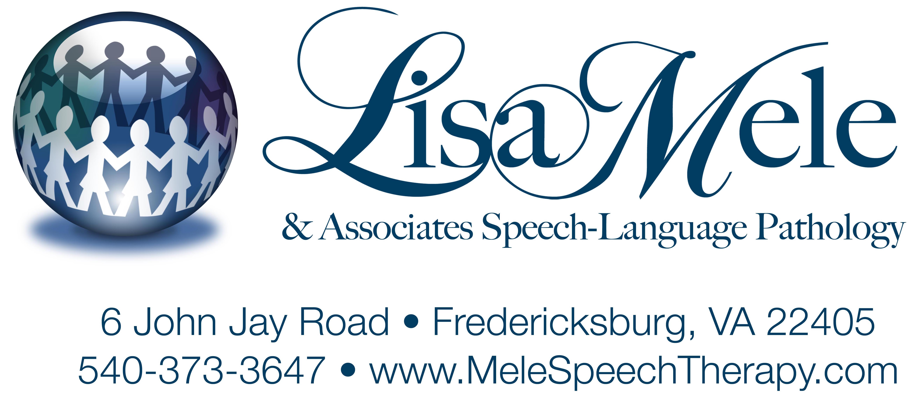
HIPAA - Your Privacy Rights

This Notice Describes How Medical Information About You May Be Used And Disclosed And How You Can Get Access To This Information. Please Review It Carefully.

Effective date:

Lisa Mele & Associates Speech-Language Pathology is required by law to keep your health information safe. This information may include:
- notes from your doctor, teacher, or other health care provider
- your medical history
- your test results
- treatment notes
- insurance information

A government rule, called the Health Insurance Portability and Accountability Act, or HIPAA, requires that you get a copy of this privacy notice. We will ask you to sign a paper saying that you have been given this notice.

Read and refer to this notice at any time to see how your health information can be used and who can see it.

How Your Health Information May Be Used or Shared
We may use or share your health information without your permission for the following reasons:
- Treatment. We may share information with doctors and other health care providers who care for you. For example, if your doctor orders speech therapy, we will share the results of our treatment with that doctor.
- Payment. We may use and share information about the treatment you receive with your insurance company or other payer to receive payment for services. This may include sharing important medical information. We may share information to:
  - get the insurance company’s permission to start treatment
  - get permission for more treatment
  - get paid for the treatment you receive

- Health Care Operations. We may use and share your health information to run the clinic and be sure that all patients receive good care. For example, we may use your health information to:
  - see how well our services are working
  - see how well our staff is doing
  - see how we compare to other clinics
  - make our services better
  - help others study health care services

Your Health Information May Also Be Used or Shared Without Your Permission for:
- Abuse and Neglect. We may share your health information with government agencies when there is evidence of abuse, neglect, or domestic violence.
- Appointment Reminders. We will use your information to remind you of upcoming appointments. Reminders may be sent in the mail, by e-mail, or by phone call or voicemail message. If you do not wish to get reminders, please tell your speech-language pathologist.
- As Required by Law. We will share your information when we are told to do so by federal, state, or local law. We will also share information if we are asked by the police or courts.
- Government Functions. Your information may be shared for national security or military purposes. If you are a veteran, your information may be shared with the Office of Veteran’s Affairs.
- Information About a Person Who Has Died. We may share information with the coroner, medical examiner, or a funeral director, as needed.
- Marketing. We may use your information to let you know of other services that might be of interest to you.
- Public Health Risks. We may report information to public health agencies as required by law. This may be done to help prevent disease, injury, or disability. It may also be done to report medical device safety issues to the Food and Drug Administration and to report diseases and infections.
- Regulatory Oversight. We may use or share your information with agencies overseeing health care. This may include sharing information for audits, licensure, and inspections.
- Research. We may share your health information with researchers to be included in their research project. Information will be shared only for projects that have been through a special approval process. These projects have rules to protect your privacy, too.
- Threats to Health and Safety. Your health information may be shared if we believe that it will prevent a threat to your health and safety or the health and safety of others.
- Worker’s Compensation. We will share your information with Worker’s Compensation if your case is being considered as a work-related injury or illness.

When Your Permission Is Needed to Use or Share Your Health Information
You must give us permission to use or share your health information for any situation that is not listed in this notice. You will be asked to sign a form, called an authorization, to allow us to use or share your information. You are allowed to take back this authorization, called revoking authorization, at any time. We will not be able to get back the information that we shared with your permission.

Your Privacy Rights
You have the right to:
- Ask us not to share your information. You can ask us not to use or share your information for treatment, payment, or health care operations. You can also ask us not to share information with people involved in your care, like family members or friends. You must ask for limits in writing. We must share information when required by law. We do not have to agree to what you ask.
- Ask us to contact you privately. You can ask us to contact you only in a certain way or at a certain place. For example, you may want us to call you but not to e-mail you. Or you may want us to call you at work and not at home. You must ask us in writing. We will do all we can to do what you ask.
- Look at and copy your health information. You have the right to see your health information and to get a copy of that information. You have a right to see treatment, medical, and billing information. You may not be able to see or copy information put together for a court case, certain lab results, and copyrighted materials, such as test protocols.
- Ask for changes to your health information. You can ask us to change information that you think is wrong. You can also ask that we add information that is missing. You must ask us in writing and give us a reason for the change. We do not have to make the change.
- Get a report of how and when your information was used or shared. You can ask us to tell you when your information was shared and who we shared it with. There are some rules about this:
  - You need to ask us in writing.
  - You must tell us the dates you are asking about and if you want a paper or electronic copy.
  - You may get information going back 6 years, but it cannot be for earlier than
April 14, 2003. This is the date when the government privacy rules took effect.

- Get a paper copy of this privacy notice. You can get a paper copy of this notice at any time. You can get a copy even if you have already signed the form saying you have seen this notice.
- File complaints. You can file a complaint with us or with the government if you think that
  - your information was used or shared in a way that is not allowed
  - you were not allowed to look at or copy your information
  - any of your rights were denied

Who Is Covered by This Notice
The people who must follow the rules in this notice are:
- all speech-language pathologists working at [insert practice name here]
- anyone who is allowed to add health information to your file, including students and other staff
- any volunteers who may help you while you are in this clinic

Changes to the Information in This Notice
We may change this notice at any time. Changes may apply to information we already have in your file and to any new information. Copies of the new notice will be available from our staff. The notice will have a date on the front page to tell you when it went into effect.

Complaints
You may file a complaint if you think we did something wrong with your information. You can complain to your regional office of the United States Office of Civil Rights. To find out more about filing complaints, go to www.hhs.gov/ocr/privacy/hipaa/complaints/index.html. All complaints must be in writing. You will not get in trouble for filing a complaint.

Contacts
If you have any questions about this notice or your privacy rights, please ask your speech-language pathologist or contact: Lisa Mele & Associates at (540) 373-3647.

